

**Institute Of Technology Of Cambodia**

**Department Of Information**

**Technology and communication**

**Technical Report**

**Subject: Combinational and Sequential Logics**

**Sequential circuit Mini project: Traffic Light**

**Lecturer: HENG RATHPISEY**

**Group: I3-GIC-C**

**Year: 2021 - 2022**

**Team: 04**

**Member ID**

**SDEUN VIRAKNON e20190961**

**TY CHHENGLONG e20191217**

**TOUN DINA e20191207**

**VEN THON e20191250**

Content

Contents

I. Introduction 3

1. Objective of project 3

2. Component overviews of system 3

II. Implementation 3

1. Component build counter 3

2. Component create Ring counter 4

3. Component create controller 4

4. Combination 4

III. Result 5

1. Responsibility of each member in group 5

2. Successful features 6

3. Unsuccessful features 6

IV. Conclusion 6

❖ Difficulty and Experience 6

# Introduction

# Objective of project

This report is an overview of our project which is about the combinational and sequential logics function. The goal of this project is to design and control system of traffic light. For simple system of this project and initializer to able to do it are:

* To build counter down
* To create circuit using true table
* To create function of traffic light
* To create Ring counter
* To create controller

# Component overviews of system

This is all element of the circuit that we have used to make this system of project are:

* Logic gates ( Nor gate, Or gate, And gate, Xor gate)
* Input ( Input, Button, Power, Constant Value)
* Output ( Output, Digital Led, Hex Display)
* Decoder & Plexers ( Multiplexer, Decoder)
* Sequential Element ( D flip flop, JK flip flop, Clock)
* Annotation ( Text)
* Mise ( Splitter)

# Implementation

# Component build counter

For to build counter this project are 5 counter:

* Counter down 9 to 0

Use JK flip flop 4 bite decade counter exhibits a truncated binary sequence and goes from 0000 through the start 1001 state. Rather than going from 1001 state to the 0001, it recycles to the 0000 state. After 0000 state get 1 tigger.

* Counter down 5 to 0

Use JK flip flop 3 bite decade counter exhibits a truncated binary sequence and goes from 0000 through the start 0101 state. Rather than going from 0101 state to the 0001, it recycles to the 0000 state and after get 1 trigger.

* Counter down 1 to 0

Use JK flip flop 1 bit decade counter exhibits to binary sequence start 0001, it recycles to the 0000 and then get 1 trigger.

* Counter down 59 to 0

Use counter down 5 to 0 combination with counter down 9 to 0, result count number 59 to 0 and get 1 trigger.

* Counter down 99 to 0

Use counter down 9 to 0 with counter down 9 to 0 and result got count number 99 to 0 and then get 1 trigger.

# Component create Ring counter

We used D flip flop 8 bits to make ring counter to be connect with controller.

# Component create controller

We used true table and 6 input to set of traffic signs.

# Combination

We connect Decoder and clock with counter down 99 to 0, 59 to 0, 5 to 0 and 1 to 0. And then connect to Multiplexer with Ring counter and controller to be set of traffic signs.

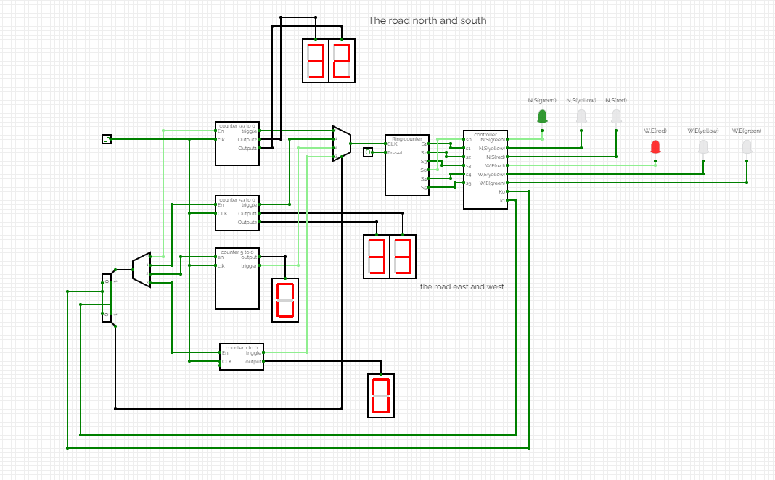

# Result

# Responsibility of each member in group

|  |  |  |  |
| --- | --- | --- | --- |
| No | Name | ID | Role |
| 1 | VEN THON | e20191250 | Leader |
| 2 | TOUN DINA | e20191207 | Reporter |
| 3 | SDEUN VIRAKNON | e20190961 | Member |
| 4 | TY CHHENGLONG | e20191217 | Member |

* Task division:
  1. VEN THON
* Prepare plan in this project and explain to members
* Research and work with simple
* Control and fix all problem in circuit
* Give solution to member
* Circuit counter down
  1. TOUN DINA
* Write the report
* Research of function
* Combine all function
  1. SDEUN VIRAKNON
* Research Ring counter
* Help draw circuit
  1. TY CHHENGLONG
* Research controller
* Test the result

# Successful features

In this project, we have completed all the features successfully.

# Unsuccessful features

As we mentioned that we have done all the features successfully but there still has one part that we have not do it yet is point tern left.

# Conclusion

# Difficulty and Experience

In conclusion, all the member worked hard on this project. So that all member shared their knowledge and some information to the team and combined the ideas together.

Upon completion of this project, one will be able to understand how to use some components in combinational circuit and know how to build sequence circuit properly. Moreover, we also learned about JK flip flop, counters, and true table. Furthermore, we could get a lot of experiences about my team work.

Thank you